Poznan, March 9, 2023
Meble Polska 2023 as strong as before the pandemic

Meble Polska – the largest furniture contracting meeting in Central and Eastern Europe – regained its pre-pandemic condition This year's edition of the fair, which took place in Poznan from February 21 to 24, 2023, was similar in size to the record event held in 2020. The number of participants increased by 19.6%, compared to the fair organised in May 2022.

Fifty-one percent visitors from abroad
A high percentage of furniture buyers from abroad is already a standard at the furniture fair in Poznan. Every year, thousands of representatives of foreign purchasing groups, wholesalers and furniture showroom chains from all over the world visit the fair. It was no different this time - the MEBLE POLSKA fair was attended by visitors from 71 countries.
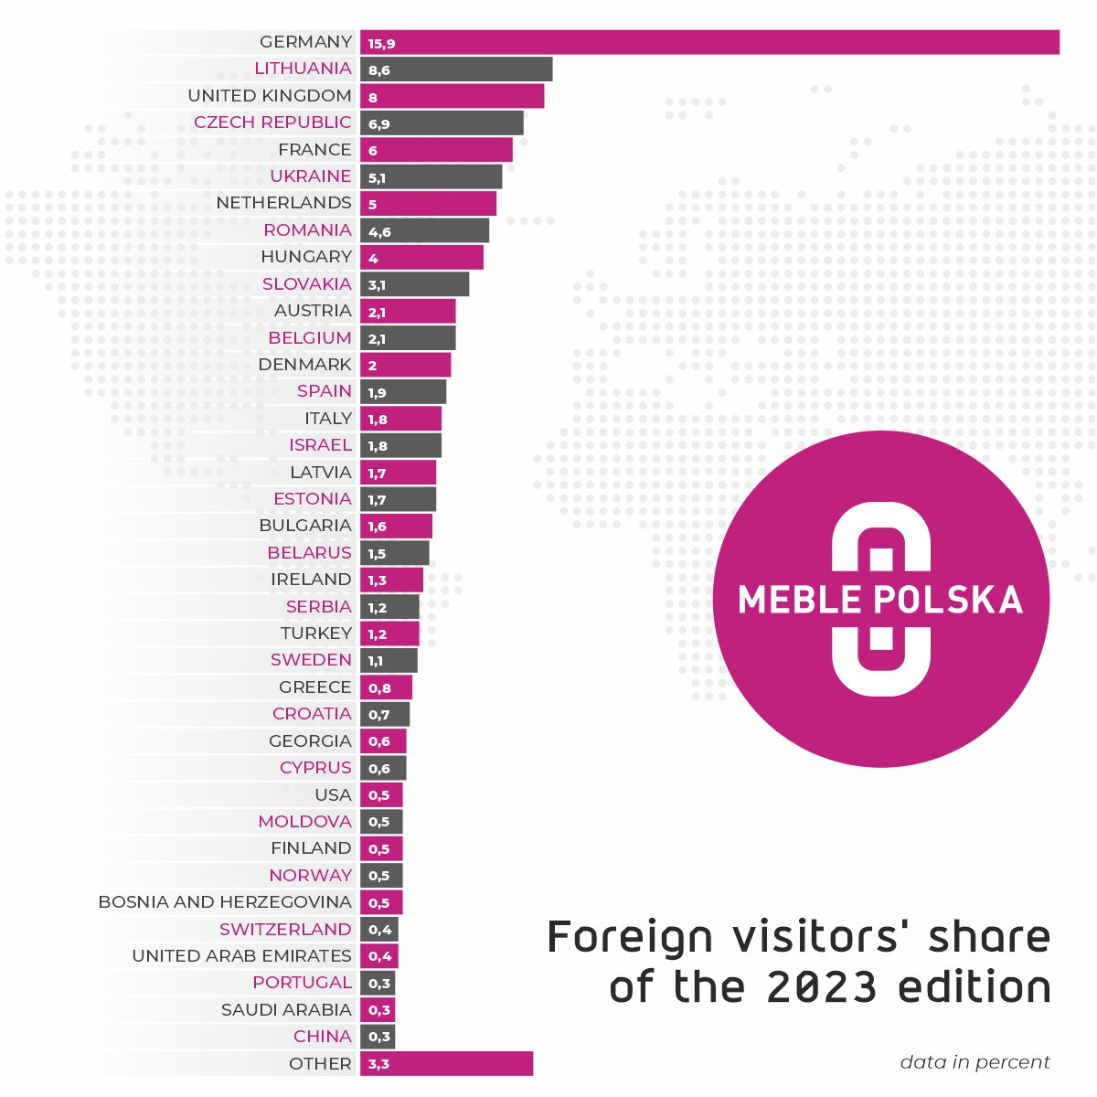
The largest group were buyers from Germany (15.9% of foreign merchants). Another significant group of fair guests came from Lithuania, Great Britain, the Czech Republic, France, Ukraine and the Netherlands. The fair stands were also visited by representatives of the furniture trade from such markets as the United States, Israel and the United Arab Emirates.
The fair was also visited by merchants from such remote countries as: Angola, Saudi Arabia, Australia, China, French Guiana, India, Jordan, Kenya, Costa Rica, Kuwait, Lebanon, Libya, Mali, Mauritius, Mongolia, Nigeria, Palestine, Peru, Sri Lanka, Uzbekistan and Ivory Coast.
The total number of fair participants amounted to 13,744 people. According to the registration data 51% of all visitors came from abroad. – The MEBLE POLSKA Fair has clearly become a global brand in the furniture industry. More than 10 years of an intensive promotional campaign abroad have made the Poznan furniture fair known practically all over the world, and foreign furniture buyers know that it is the best place to see the offer of the Polish furniture industry – says Józef Szyszka, the director of the MEBLE POLSKA fair.
Storefront for Polish furniture
The exhibition was organised in the MTP pavilions 3, 3A, 5, 5A (Home Decor), 6, 8 and 8A, taking over the total area of 55,000 square meters. The exhibitors presented products from all price segments: upholstered furniture, case furniture made of furniture board and solid wood, chairs, tables and mattresses. The latest furniture collections for the next sales season were presented in Poznan by majority of the most important Polish manufacturers. The exhibition was also attended by many new companies that exhibited at MEBLE POLSKA for the first time or returned to this event after a long break.
For several years, the number of foreign companies actively looking for global clients in Poznan has been growing. This year, the exhibition was attended by furniture manufacturers from China, Cyprus, Denmark, Lithuania, Germany, Romania, Serbia, Slovakia, Sweden, Turkey, Ukraine, Uzbekistan and Italy. As in May 2023, a large national presentation was organized by the Ukrainian Association of Furniture Manufacturers.
263 companies from 14 countries presented their offers during the fair, including HOME DECOR event.
Gold for the best
On the first day of the fair, the winners of the Gold Medal competition received their awards from the president of the jury, Professor Ewa Ratajczak, and the vice-president of the MTP Group, Elżbieta Roeske. The statuettes were awarded for 15 distinguished products:
- Candelo System – Fabryka Mebli WERSAL Z.B.Ł. Kaczorowscy Sp.k.
- COMO – corner sofa with adjustable backrest depth – POLDEM Sp. z o.o. POLDEM Group/ STELLA Sp. z o. o
- Genesis – COMFORTEO Węgłowski i Stryjakiewicz Sp.k.
- Eris Collection – WAJNERT MEBLE Sp. z o. o
- Fabryka Mebli TARANKO Aleksander Taranko
- Sempre Collection – WAJNERT MEBLE Sp. z o.o
- 4Senior non-stigmatizing furniture line – TOBO Sp. z o. o
- "Ovalo" upholstered bed – STOLWIT MEBLE Sp. z o.o Sp. k.
- Bed with Pola bedside table – THE BEDS – STWD ROMAN BILECKI
- OXYGEN PLUS mattress – COMFORTEO Węgłowski i Stryjakiewicz Sp.k.
- SENMATIC Mattress – BFM Sp. z o.o.
- S-tube mattresses – MATROLUXE POLAND Sp. z o. o
- Dolce Vita modular furniture – COMFORTEO Węgłowski i Stryjakiewicz Sp.k.
- Seledo System – Fabryka Mebli WERSAL Z.B.Ł. Kaczorowscy Sp.k.
- TREZZO – corner sofa with a sleeping function mechanism – POLDEM Sp. z o.o. POLDEM Group/ STELLA Sp. z o. o
This year, members of the competition jury, for the first time, additionally awarded two special distinctions. The Grand Prix of MTP Group for the most innovative product among all those nominated for the Gold Medal was awarded to the 'Pola' collection by THE BEDS–STWD Roman Bilecki. In this case, the attractive design, the combination of natural construction and upholstery materials, as well as the precision of workmanship and functionality of this furniture were appreciated. – Here we can detach the upholstered elements for cleaning or replacement, the advantage is also the silent closing and full extension of the drawers – says Prof. dr hab. Ewa Ratajczak, Chairwoman of the Competition Jury.
In turn, prestigious Eco Prize award went to MATROLUXE POLAND for the 'S-tube mattress'. It is a mattress in a tube (7 layers as an option), which is vacuum-packaged to fit parcel lockers. The innovations include the construction of the mattress which consists of two independent parts (the base and the so-called topper), connected by a zipper, which can be replaced as needed. Out of concern for the environment, MATROLUXE POLAND has used natural resources – the cover is made of linen, and the mattress itself can be recycled.

Training for furniture retailers
The MEBLE POLSKA fair was accompanied by interesting seminars, lectures and discussion panels. Traditionally, on the first day B+R Studio presented its report "Polish Furniture Outlook – perspectives for the Polish furniture industry Every year, this publication provides the latest data on market forecasts and values, the economic situation, furniture sales in Poland and the dynamics of foreign trade.
The whole day was devoted to the owners of furniture stores. The lectures provided a lot of practical knowledge – especially important now, when sales are becoming more and more difficult.
A series of interesting lectures was also prepared by Unity SA. They presented global trends in business development and solutions supporting sales and digitization of companies in the furniture industry. In turn, the lecture "Eco-design – the perspective of the Polish furniture industry" provided by the Łukasiewicz Research Network – Poznan Institute of Technology, perfectly matched the trend of sustainable production, which may be an opportunity for Polish manufacturers to increase their competitiveness.
In response to the growing interest of Polish furniture companies in the American market, the Polish Chamber of Commerce of Furniture Manufacturers invited experts from the Polish Investment and Trade Agency to participate in the program accompanying the fair and they provided valuable tips on how to export products to the USA and Canada. During the panel discussion, participants had the opportunity to learn more about the business culture, customer expectations, logistics and free trade agreements in both countries.

MEBLE POLSKA 2024
The next edition of the MEBLE POLSKA Fair will take place as usual in the last week of February – from February 20 to 23, 2024. – Next year's edition promises to be very positive. We already have information from this years' exhibitors and from new companies that they want to present their offer in Poznań at the fair in February next year – says Józef Szyszka.

