Meble Polska – Gold Medal 2023

- Candelo System  Fabryka Mebli WERSAL Z.B.Ł. Kaczorowscy Sp.k.  The extremely comfortable, modular Candelo collection allows you to independently configure the individual elements of the furniture. It will surely satisfy all lovers of good design. It combines comfort with elegance. The extremely interesting form of the furniture will work in modern interiors as a family recreation zone. The ability to combine individual elements allows you to adjust the size of the furniture to the space you have. It is an ideal solution in the arrangement of difficult and demanding spaces. The collection also gives you the option of choosing the depth of the seat, thanks to which each user will adjust it to individual needs. The seat and backrests are filled with highly elastic foam of a very high standard. Particularly noteworthy are the additional backrest cushions dedicated to the collection, with the possibility of adjusting the head support angle and improving the position during rest. So the comfort of rest can be adapted to the individual needs of users. The CANDELO collection was the winner of the 17th edition of the 'Furniture Diamond' competition in the category: COMFORT ZONE / PREMIUM CLASS. The awarded prize confirms the originality and high quality of the product. | 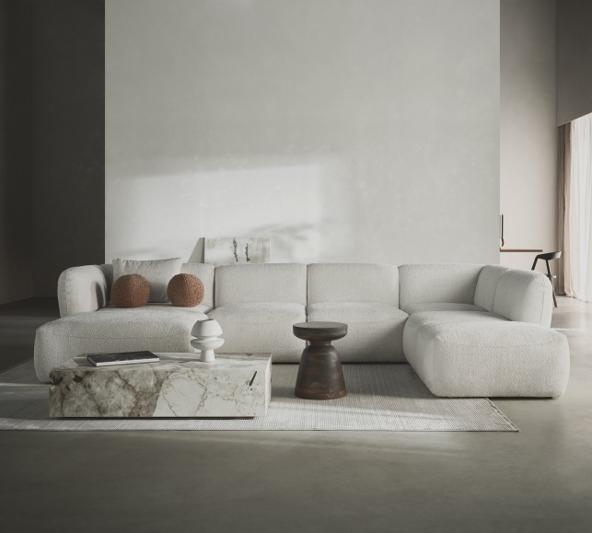
- COMO – corner sofa with adjustable backrest depth  POLDEM Sp. z o.o. Grupa POLDEM / STELLA Sp. z o.o  The product line was designed for very large modern style living spaces. The system provides an above-average number of corner configurations and the possibility of free designing various spatial arrangements using the modules, including 'vis a vis' setup. All modules in the standard version are fully upholstered so they can be alternatively used as free-standing elements. Naturally, in order to maintain the desired aesthetics of the body in this case, appropriate side connectors were used, which can be freely concealed. The concept of the COMO corner sofa has also been created to meet the need of exceptional freedom of 'colour play', i.e. the possibility of using modules in different colours of upholstery fabric. This solution not only highlights the originality of the design itself, but primarily it is intended to give the effect of sublime visual harmony with the interior characterised by diverse colours. The collection provides an exceptionally high comfort of use, resulting primarily from spacious, deep seats, as well as from the use of a backrest sliding mechanism, thus enabling seat depth adjustment. In addition, the corner modules can be optionally equipped with a sliding mechanism connected in parallel with a rotation option that allows you to set the backrest in the preferred direction. The sofas manufacturing process meets the highest environmental and ergonomic standards. The furniture is available in a wide range of textile upholstery with a highly diversified design and colour scheme. | 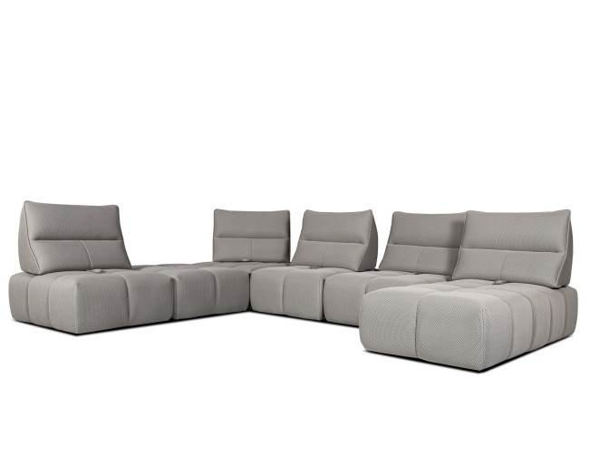
- Genesis  COMFORTEO Węgłowski i Stryjakiewicz Sp.k.  The inspiration to create the Genesis bed was the need for closeness between man and nature. The rounded shapes characteristic of the bed refer to the gentle shapes of plants, while at the same time being in line with the current interior design trends. The combination of two seemingly different fabrics – patterned, jacquard with soft boucla, together creates a harmonious duo. The base of the bed comes with two integrated bedside tables with tops made of walnut wood. The Genesis bed was awarded the Furniture Diamond 2023. | 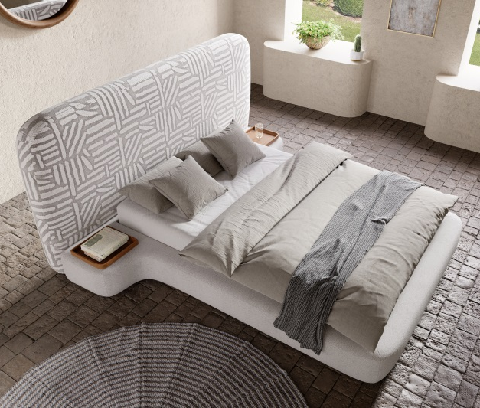
- Eris Collection  WAJNERT MEBLE Sp. z o.o.  The ERIS modular system of sofas and corner sofas has been designed with a modern apartment in mind. This aesthetic and functional lounge furniture offers great arrangement possibilities and fits into any modern large or small living space. The adjustable headrests will meet all your personal comfort requirements, and thanks to the electric extension in the seat, you can perfectly adjust the furniture to your needs. | 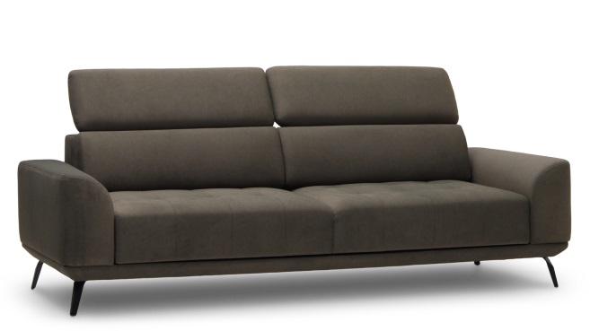
- SANTOS Ccollection  Fabryka Mebli TARANKO Aleksander Taranko  The SANTOS Collection refers to the ArtDeco trend, which is successfully returning to our interiors and is one of the leading directions of interior design in the coming time. The collection is a perfect reflection of minimalism in an elegant style and a reference to modernism. The forms with slightly rounded lines aesthetically combine the colours of solid oak wood with black modern handles, frames and legs. The main decorative elements are the grooved fronts. | 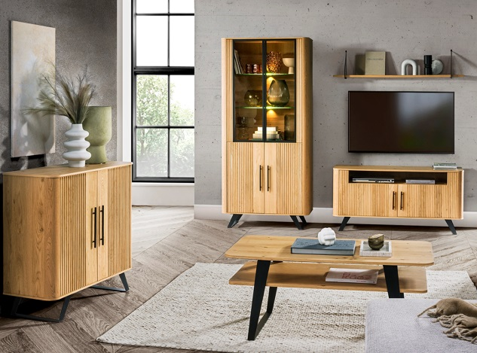
- Sempre Collection  WAJNERT MEBLE Sp. z o.o.  WE PRESENT SEMPRE – our new regular-form collection with electric seat extension up to 60 cm. Don't be fooled by the straight lines. SEMPRE is a dream come true. The SEMPERE sofa and corner sofas are perfect for relaxing together with the whole family or alone. | 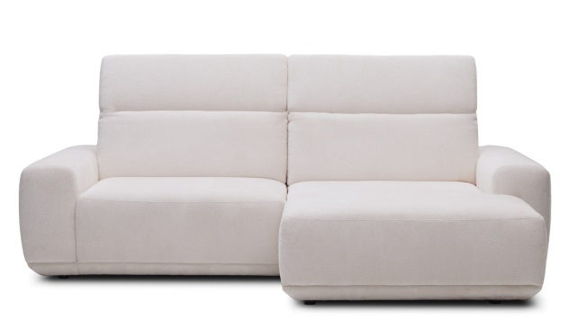
- 4Senior non-stigmatising furniture line  TOBO Sp. z o.o.  The 4Senior non-stigmatising furniture line is a product innovation intended for the elderly. It is a combination of high-quality products with additional features affecting modern design, comfort and safety of use. Their mobile nature facilitates free movement and the use of boards with a reduced amount of formaldehyde reduces the level of harmful substances in the air. The furniture fits perfectly both in the interiors of flats and in specialist nursing homes. | 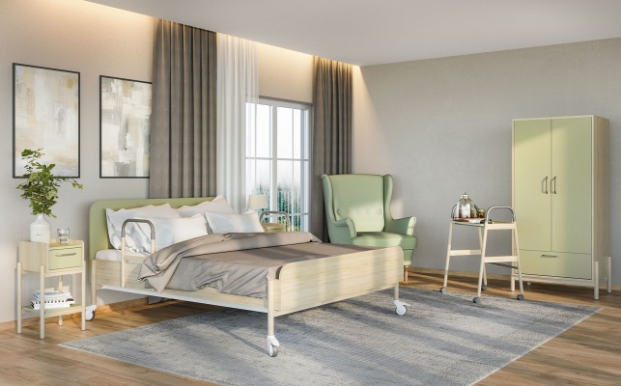
- 'Ovalo' Upholstered bed  STOLWIT MEBLE Sp. z o.o. Sp. k.  Ovalo – a bed with character that can even be placed in the centre of the bedroom. The original design and unique combination of metal and upholstered elements distinguish the bed from similar flat models. The modern, upholstered Ovalo bed with a levitating headboard with an oval cross-section, forward-curved sides and adjustable backrest height (105cm, 110cm and 117cm) allows you to rest comfortably also in a sitting position, and maintain a healthy spine. The bed can have a practical container for bedding, easily lifted thanks to an electric frame or a frame with gas actuators. | 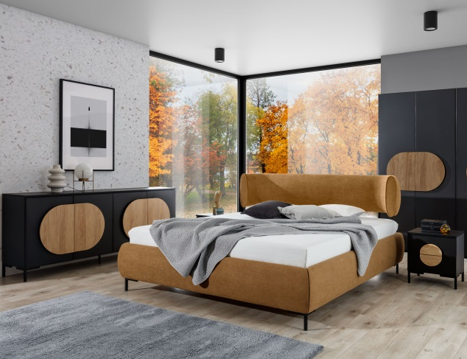
- Pola bed with a bedside table GRAND PRIX  THE BEDS – STWD ROMAN BILECKI  Style and elegance. This is how you can briefly describe a bed with an upholstered headboard from the Pola collection. Its classic form has been enriched with the highest precision. It can be seen in the smallest detail, which has been smoothed, sanded and properly painted. Oak wood is one of the most valued materials. It is durable, does not discolor and has a natural, beautiful shade. It will be perfect in the bedroom. Adding an upholstered panel to the headrest in this case is a very original solution. This, however, allowed to obtain an interesting, elegant combination of fabric and wood. The bedside table has everything you need, i.e. a tabletop for things that must be at hand at night and a drawer for what should be hidden. The cabinet has an extra hidden feature: a built-in breakfast box so you can enjoy your coffee in bed with your partner. | 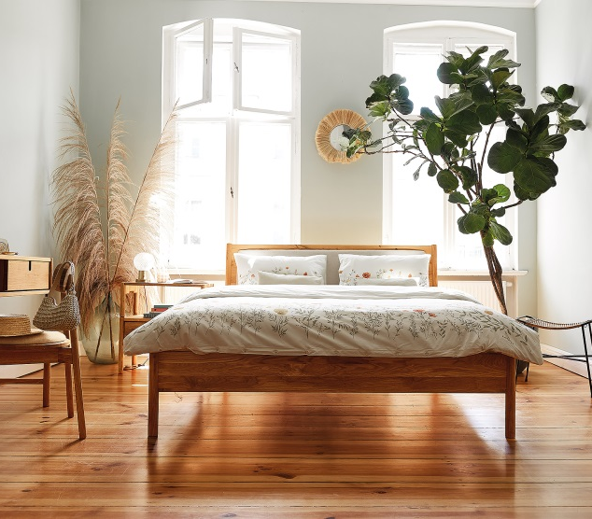
- OXYGEN PLUS Mattress  COMFORTEO Węgłowski i Stryjakiewicz Sp.k.  This model addresses two key challenges of good recovery while sleeping. Firstly, it provides adequate support for the spine, and secondly, it ensures proper oxygenation of our body. Thanks to this, we sleep as if more 'intensely' – that is, even a slightly shorter sleep gives us the feeling of being rested. Using the Oxygen plus mattress for sleeping improves concentration, memory, immunity and mood during the day. In addition, it lowers blood pressure, protects against migraines, back pain, and numbness of the limbs. And finally – it strengthens the hair and has a good effect on the appearance of our skin. | 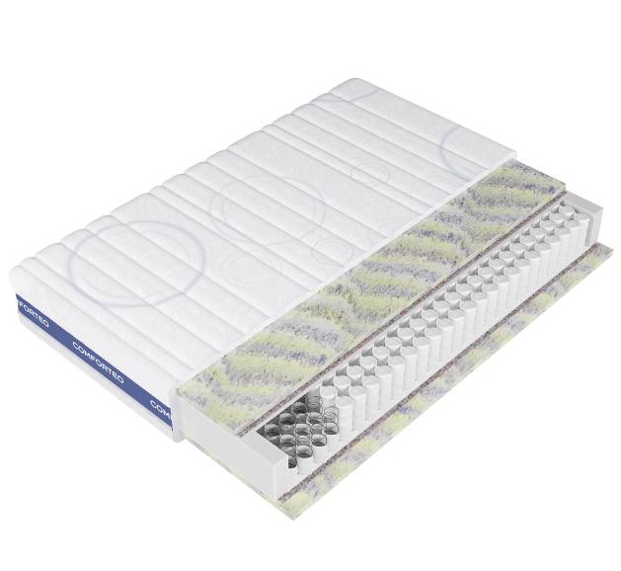
- SENMATIC Mattress  BFM Sp. z o.o.  The Senmatic mattress is a revolutionary and innovative solution that will meet the needs of even the most demanding users. From now on, you don't have to compromise because the Senmatic mattress will 100% adapt to your needs. Smooth and independent adjustment of the hardness of individual zones of the mattress will guarantee the highest comfort of use. Using the remote control or smartphone, you can choose the perfect hardness of the mattress, which will ensure the perfect position and support for the spine, regardless of your body shape. | 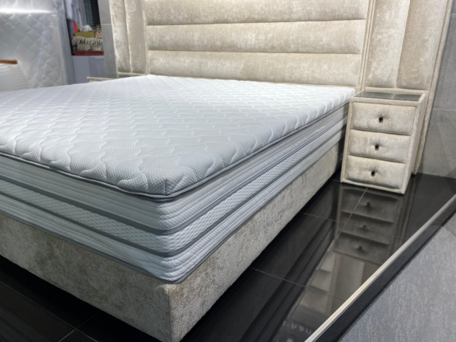
- S-tube Mattresses ECO PRIZE

MATROLUXE POLAND Sp. z o.o.

The future is just around the corner: the revolutionary S-tube ─ a mattress in a tube. We learned to carry our lives in our pockets and wash a mountain of dishes at the touch of a button. Mankind has learned to reinvent the telephone, the card, the iron and the computer. The list is endless. A new leap, new, improved form is a small revolution in the world of things that makes our lives more comfortable, more compact, more pleasant. The portable S-tube is our new invention, an exclusive, revolutionary mattress in which we have combined the most important: synchronisation and design! We are proud to announce that we have achieved the global goal of reinventing the mattress by creating the possibility of choosing individual comfort. The S-tube is everything a regular mattress offers, but it is ahead of its time and creates more portable solutions. Thanks to S-tube you will never be able to talk about mattresses in the past tense!

- Modular furniture – Dolce Vita  COMFORTEO Węgłowski i Stryjakiewicz Sp.k.  Dolce Vita is a modular upholstered piece of furniture that allows you to create any form of leisure furniture at any time: corner sofa, sofa, U-form, armchair, etc. Each of these forms can be used in any combination (e.g. a large corner sofa with several ottomans; with or without backrests) and in any dimensions that duplicate the dimensions of the individual modules. Each module was designed on the basis of simple geometric forms. As a result, it allows you to maintain a minimalist, lightweight form, even if many modules are used to create a very substantial whole. The advantages also include the possibility of a quick replacement, for example, of a large corner sofa with a couple of small sofas and armchairs, placed separately at the coffee tables – which will give the impression of a large set of seating furniture. The height and depth of the seat are conducive to relaxation in a reclining position, which makes the Dolce Vita model perfect for casual social meetings, as well as for public spaces such as clubs or waiting rooms. The Dolce Vita modular furniture line has already been appreciated by the jury of the nationwide competition Diamond of Furniture – in 2022 it was awarded first place in the Comfort Zone in the premium class category. | 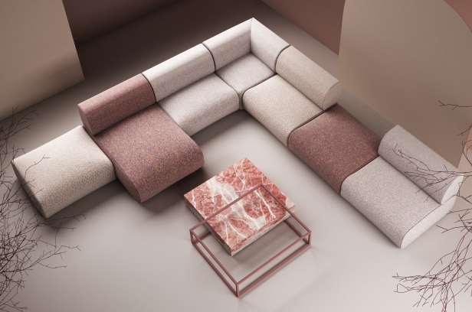
- Seledo System  Fabryka Mebli WERSAL Z.B.Ł. Kaczorowscy Sp. k.  The Seledo collection is a functional corner sofa system, dedicated to all those who appreciate modern design. With the electrically adjustable seat extension and a set of soft, loose backrest cushions you can take the most comfortable position while resting. The furniture is placed on high, black metal legs, which increase its aesthetic and utility values. Thanks to this, the structure of the furniture gains lightness. It also allows easy access to floor cleaning equipment. The Seledo collection is perfect for modern and minimalist interiors, where, regardless of the size, a good quality piece of furniture always looks original and intriguing. | 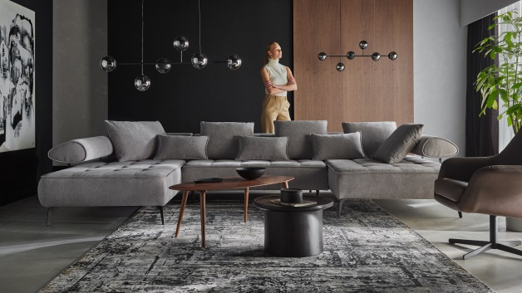
- TREZZO – corner sofa with a sleeping function mechanism  POLDEM Sp. z o.o. Grupa POLDEM / STELLA Sp. z o.o.  The TREZZO system is a proposal with a fairly universal design line, dedicated primarily to the arrangement of modern interiors, but fitting equally well into those maintained in a more classic style. The collection includes a wide range of modules, i.e. conventional sofas and forms that allow you to create plenty of corner configurations. The main seat modules of both corner sofas and sofas can be optionally equipped with a sleeping function mechanism. The sofas distinguished by their spatial form, created with the use of deep seats and spacious backrest cushions, ensure exceptional comfort of rest. Their rounded shapes appropriately accentuate the sense of above-average usability. The sofas manufacturing process meets the highest environmental and ergonomic standards. The furniture is available in a wide range of textile upholstery with a highly diversified design and colour scheme. | 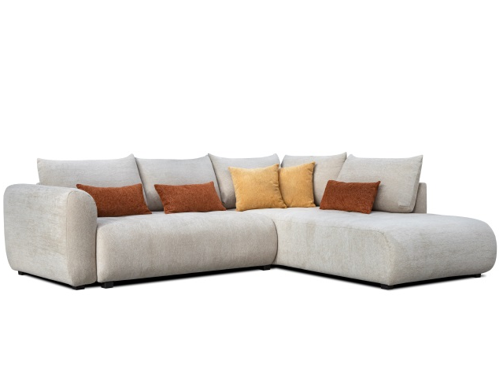

Members of the jury for the first time, additionally awarded two special prizes. The Grand Prix for the most innovative product among all the Gold Medal nominees was awarded to the "Pola" collection by THE BEDS-STWD Roman Bilecki. Appreciated in this case was the attractive design, the combination of natural construction and upholstery materials, in addition to the precision of manufacture, as well as the functionality of this furniture. - Here we have the possibility of disassembling upholstered elements for cleaning or replacement, the advantage is also quiet closing and full extension of drawers, says Prof. Dr. Ewa Ratajczak Chairman of the Competition Jury.

The prestigious Eco Prize was fully deserved by the product "S-tube mattresses" from MATROLUXE POLAND. This is a mattress in a tube (it has 7 layers as an option), thanks to vacuum packing it can be delivered to parcel machines. Innovative is, among other things, the construction of the mattress, which consists of two independent parts (the base and the so-called topper), connected by a zipper, which can be exchanged as needed. Out of concern for the environment, MATROLUXE POLAND has used natural resources - the cover is made of linen, and the mattress itself can be recycled.

